Pattern Recognition Pablo Castro Ilundain
Exercise 7: Statistical classification and parameter estimation
Question 1:
Based on the Multivariate I-dimensional Gaussian PDF we can calculate each single feature and based on that, I have plotted all the values on the 3d plane just to see how the different probabilities of the features acted with each other’s (the decision boundaries).
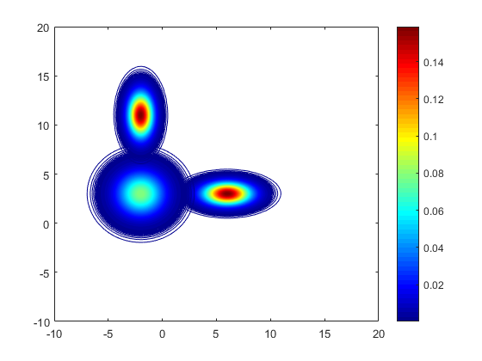
Question 2:

